Project Design Phase-II
Data Flow Diagram & User Stories

Date | 25 December 2025
Team ID
Project Name | SkyBooker-Flight-Booking-Application
Maximum Marks | 4 Marks

Data Flow Diagrams:
Example: DFD Level 0

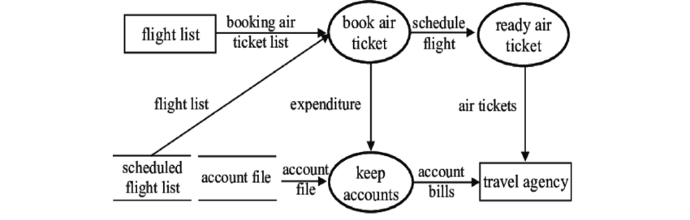

User searches flights → System retrieves airline data → User selects flight → Payment processed → Booking confirmed.

User Stories

User Story Table – Freelance Finder
User Type | Functional Requirement (Epic) | User Story / Task | Acceptance Criteria | Priority | Release
Traveler | Flight Search | As a traveler, I can search for flights by entering origin, destination, and dates. | Results display valid flights matching the search criteria. | High | Sprint-1
Traveler | Flight Browsing | As a traveler, I can filter search results by price, duration, and airline. | List updates instantly based on selected filters. | Medium | Sprint-1
Traveler | Booking Process | As a traveler, I can select a flight and enter passenger details to book. | Booking summary is displayed correctly before finalization. | High | Sprint-1
Traveler | Seat Selection | As a traveler, I can choose my preferred seat from a real-time seat map. | Selected seat is reserved and added to the cart. | Medium | Sprint-2
Admin | Flight Management | As an admin, I can update flight schedules and cancel flights if necessary. | Status changes are reflected on the user’s dashboard immediately. | High | Sprint-1

